Name: Vivek Vikram Pundkar

Roll no: 77

GR no: 11910860

Division: C

Batch: 3

**Quick Sort**

--------------------------------------------------------------------------------------------------------------------------------------

#include <iostream>

using namespace std;

// Swap Function

void swap(int *a, int *b)

{

int t = *a;

*a = *b;

*b = t;

}

// Print Function

void printArray(int array[], int size)

{

int i;

for (i = 0; i < size; i++)

cout << array[i] << " ";

cout << endl;

}

// function to rearrange array

int partition(int array[], int low, int high)

{

int pivot = array[high];

int i = (low - 1);

for (int j = low; j < high; j++)

{

if (array[j] <= pivot)

{

i++;

swap(&array[i], &array[j]);

}

}

swap(&array[i + 1], &array[high]);

return (i + 1);

}

void quickSort(int array[], int low, int high)

{

if (low < high)

{

int pi = partition(array, low, high);

quickSort(array, low, pi - 1);

quickSort(array, pi + 1, high);

}

}

int main() {

int x[] = {9,5,0,1,15,2,6,3};

int n = sizeof(x) / sizeof(x[0]);

cout << "Unsorted Array: \n";

printArray(x, n);

quickSort(x, 0, n - 1);

cout << "Sorted array in ascending order: \n";

printArray(x, n);

}

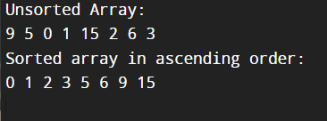

--------------------------------------------------------------------------------------------------------------------------------------------

**Time Complexity**

Best O(n*log n)

Worst O(n2)

Average O(n*log n)